TASK 2(20)

I Identify subjects, verbs, and objects in sentences.
Step 1 Underline the subjects with one line.
Step 2 Underline the verbs with two lines.
Step 3 Circle the objects.
Step 4 Write S, V, or O in brackets after each underlined or circled word.
1. My youngest brother is(V) in high school.
2. He watches TV and does homework at the same time.
3. He works at a shopping mall.
4. He likes his job but doesn't like his boss.
5. His job is easy and pays well.
6. This semester, he is taking extra classes.
7. He will go to college next year.
8. He speaks and understands English very well.
9. On weekends, he and his friends play soccer.
10. He doesn't have a girlfriend yet.

II
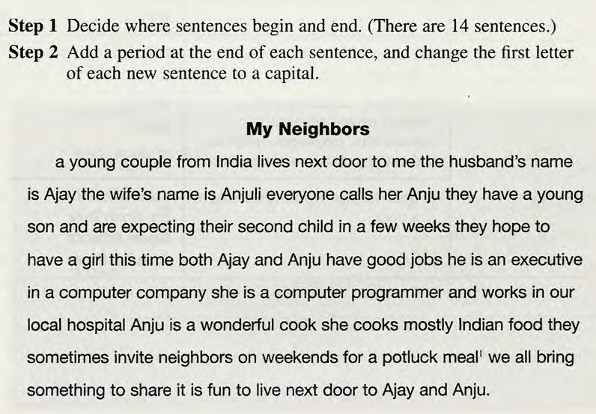

III In English, there are many rules for using capital letters. Here are six important ones.
Give your own examples to these rules:(Приведите СВОИ СОБСТВЕННЫЕ ПРИМЕРЫ НА ЭТИ ПРАВИЛА)
Rules | Examples
Capitalize
1.The first word in a sentence.
2.The pronoun I
- Names of people and their titles.
BUT NOT a title without a name.
4.Nationalities, languages, religions, and ethnic groups.
5.Names of school courses with numbers.
Note: Don't capitalize school subjects except names of nationalities, languages, religions, and college classes with numbers.
6.Specific places you could find on a map.

